**RRI Scan Software Overview**

Updated Nov 2012

1. **Software Entry**

The operation of the scan system is controlled through the vi named mastercontrol.vi (or could be mastercontrol.exe if a runtime version). Mastercontrol is a portal to all components of data acquisition and motion control. The software is compiled in LabVIEW 2012. Run the software by pushing the right pointing arrow at the upper left corner of the window (Blue circle). Some settings will be configured based on location and some will be changed based on the scan mode. Many of location specific settings are access in block diagram and can be viewed by hitting <CTRL>-E

Basic control of motion stages can be handled in section surrounded by the Green Box. Click the buttons to open a motion interface, return to home, change global velocity or acceleration, or designate a scan overshoot (in mm). The Options Area (Red Box, may not have all options in figure depending on configuration) sets up global values for special conditions.

Scan Modes (purple box) opens the actual scanning interface program Go. To end program execution, push exit.

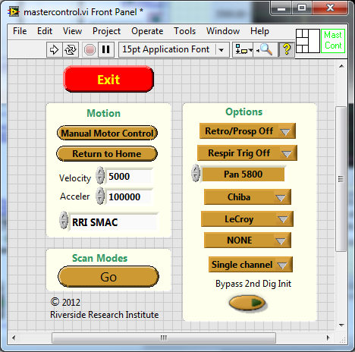

Rather than go into every operation in detail, make sure that the Show Context Help option under the Help tab is checked. Then, when a mouse is over a control, you will see text describing what the control does and any special considerations that are relevant. For the most part, the context help acts as the documentation.

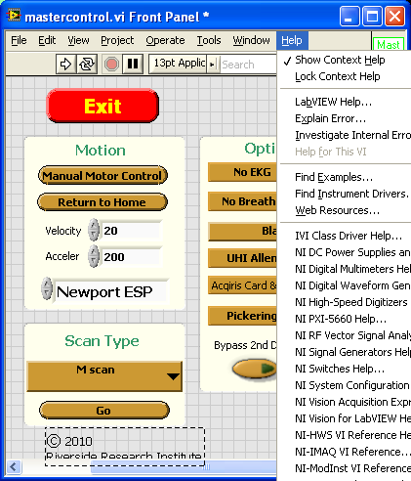

1. **Data Acquisition**

After pushing Go, you enter the data acquisition and display interface.

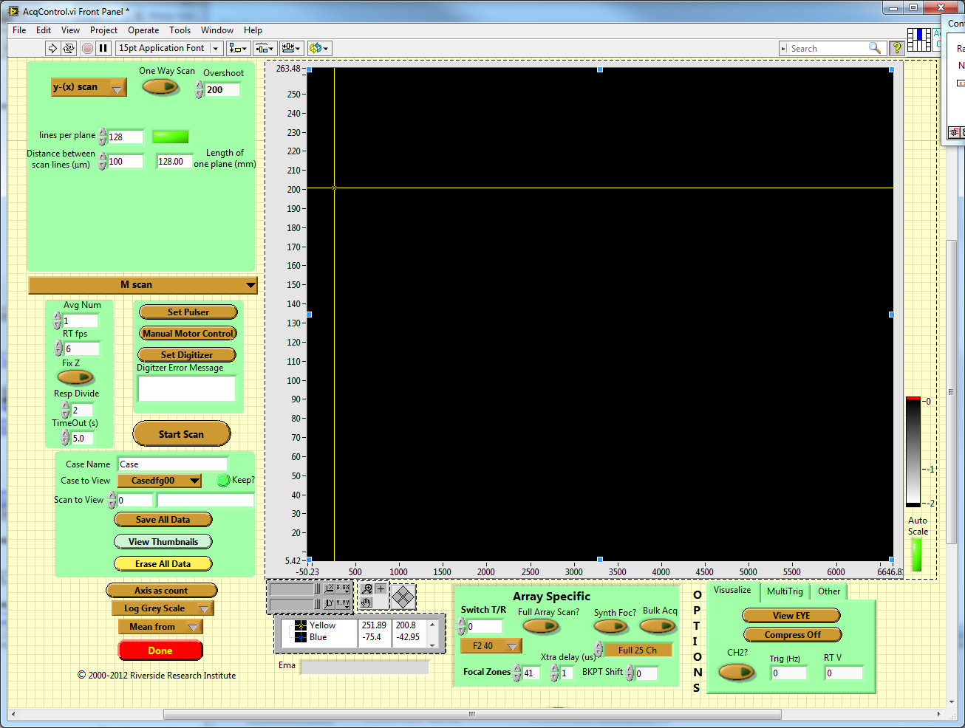

On the left, parameters related to scanning are entered. The parameters will dynamically adjust, based on the scan mode that is selected (brown oval pull down menu). Acquire data by pushing Start Scan (Red oval). Data is stored in a ~\TempBuff until it is saved or erased. Saved date gets saved in ~\Temp. In the lower right corner, there is a tab for Visualize and a control to open the ViewEye.vi program. This reads the RRI style *.eye files. ViewEYE is also a stand-alone program.

The actual RF data is selected by pushing Set Digitizer (orange oval). This opens yet another window where an active RF trace is shown. This window acts more or less like an oscilloscope. The data that will be acquired is between the yellow and red lines in the live trace window. If using a LeCroy, need to pay close attention to sampling rate and number of pts on the LeCroy itself. These values are interconnected and adjust based on the timebase setting.

Most of the information on inputs is visible in the Context Help window, but it is important to stress that the Sampling Rate represents the sampling rate for when you actually acquire data and not the sampling for the live trace (NOTE: This does not apply to the LeCroy. Sampling rate is based on whatever sampling rate the LeCroy is operating at.) The live trace is sampled based on the Time Scale per Div setting. (NOTE: This value is read of a LeCroy and cannot be set within software.)

The software can handle Acqiris hardware, NI-Scope based digitizers, and newer LeCroy scopes such as Waverunner 6050. The software dynamically adjusts to the resolution of the digitizer.

Data is saved in binary integer format with a 1024 header. See EyeHeader.xls for header fields. Labview and Matlab routines are available to work with the data.

1. **Cabling**

Cabling depends on location but typically involves some kind of box that switches programmatically between a fixed PRFsource, motion triggers, and gating or other trigger sources. In most cases, the Sync output of a function generator needs to be used and connected to the interface box.

Cabling can vary based on configuration but typically has an interface box linked to an NI DAQ card to handle trigger signals the trigger from the switch box triggering a pulser/receiver and digitizer.

Inputs:

Motion Trigger: This comes from the motion unit and carries the spatial triggers.

Function Generator Synch: Used as the PRF source if unless the system is using an internal counter as the PRF source. (This is selected in AcqControl if a change from default is needed).

EXT Trig: This is a gate signal that can be added as an extra layer of trigger. Acquisition is held up until the gate trigger is detected.

Outputs:

System Trigger: This is the output that goes to digitizer and pulser/receiver. It passes trigger based on the scan mode.

CTR output: This is an alternate trigger used for some special cases such as MultiLine triggering.

1. **Software**

Besides LabVIEW 2012 or the 2012 RunTimeEngine, the Measurement and Automation Explorer needs to be installed (Download latest version or use the NI Device Driver Install CD if you recently purchased something from NI. A fresh LabVIEW install will install all the components). The NI components for NI-VISA, NI-Scope, NI-Motion and NI-Switch should be selected and installed during the install process. They are listed under NI Devices. In addition, Pickering Switch (pipx40vpp-31.exe), Acqiris 4.2a (8 and 12 bit drivers), and Tabor 1281A (WW1281_2_ww1281drv.exe) drivers need to be installed. Also, LeCroyScope.3.0.9.0.msi and LeCroyVICPPassportInstaller.exe and needed. All these components need to be installed even if hardware is not used.